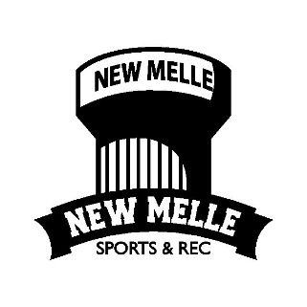

**PATNERING WITH NEW MELLE SPORTS AND RECREATION TO TACKLE SUPPLY CHAIN CHALLENGES.**

**OPM 6930**

**Rebecca McDonough**

**April 19, 2023**

**GROUP 3 TEAM:**

Hari Prasath Jothiswaran

Gnan Srivarsh Bekkesula Narahari

Yashwanth Majji

Yi-Hsuan Chan

Renukalaxmi Dudhe

Jiderechukwu Becky Ogbodo

1. ***- Background:***

Every organization (both for profit and nonprofit) strives to create a holistic environment, engage a collaborative workforce, and elect/appoint a committed leadership to continuously drive improved operational excellence that can always be equated to higher profit margin (Competitive Capabilities International, 2022).

New Melle Sports and Recreation, Inc. (NMSR), a volunteer operated, 501 (c) 3 non-profit organization, strives to serve the city in order to become the center of attraction through the attainment of operational excellence that could be equated to enough profit margin that should be sufficient to service, maintain and grow its facility to the satisfaction of its users, majority users being the residents of the City where NMSR is situated. (Newmellesports, n.d.).

NMSR has been the center for its city activities and youth programming since 1953 and is currently managed by volunteer board members and supported by parents and community volunteers. NMSR mission and philosophy are to create the civic spirit and community inclusiveness for its residents by creating opportunities for children to learn and play organized sports and parents commit to serve as role models, working together to achieve the community's common bonding goal. NMSR needs to profitably operate to accomplish its mission (Newmellesports, n.d.).

This report summarizes our analysis on NMSR’s strengths, weaknesses, opportunities, and threats and how each of the four elements can be a factor in NMSR Capacity Planning, Capacity Utilization, Demand Forecasting/Planning and Demand variability with recommendations for NMSR’s Capacity optimization, Process and Operations Improvement and optimization.

1. ***- SWOT Analysis:***

SWOT analysis is a strategic management tool used to assess internal and external factors, including Strengths, Weaknesses, Opportunities, and Threats (Kuligowski, 2023). It helps businesses optimize operations and develop effective strategies for their goals. Below are summarized strengths, weaknesses, opportunities, and threats for NMSR.

2.1 NMSR’s Strengths

* The NMSR facility is situated in a serene, secure, and picturesque community.
* NMSR has a longstanding reputation as a well-known and established organization.
* The sports facility at NMSR is capable of hosting events that attract visitors from neighboring cities, potentially generating additional income multiple times a year.
* NMSR has a proficient and experienced team that efficiently manages the organization with transparency.
* NMSR offers diverse activities, including youth sports programs and other recreational options, to provide affordable entertainment for residents (*YOUTH SPORTS | Newmellesports*, n.d.).

2.2 NMSR’s Weaknesses

* Based on Google reviews, no quick access from the parking lot to the fields. Besides, concession stands are also far away from ball fields to parking lots (*Before You Continue to Google Maps*, n.d.).
* No Handicapped access available to access the seats in field 1(*Before You Continue to Google Maps*, n.d.).
* Website operation is not convenient and less consistent in system page design. For example, when you want to rent a pavilion, you will jump to another interface for operation.
* NMSR has a lower Social Media Presence and lack of advertisement according to the number of followers and “likes” on Facebook.
* For pavilion rental, the price is higher than our competitor. Chesterfield Arts & Recreation offered residents a $25 less price than us, which is $75(*City of Chesterfield, Missouri | Pavilion Rental*, n.d.).
* Medium- and Long-term plans are nonexistent.
* Shortage of parent volunteers for football.
* Batting Cages are heated up for the whole year, thus, it’s under-utilized during summer because there is no Air Conditioner for cooling.
* Cracked plastic on playground equipment has been complained by tourists in Google reviews as a danger to children (*Before You Continue to Google Maps*, n.d.).
* Absences of Board Members at some important point as all the Board Members are volunteers.

2.3 NMSR’s Opportunities

* Volunteer Recruitment-   
  Recruiting volunteers is a valuable way for nonprofits to expand their programs and activities, while also providing individuals with opportunities to contribute to their communities. Thus, NMSR has an opportunity to recruit volunteers who are truly passionate about giving back to the community.
* Provide more sports programs-   
  NMSR can use current places for pickleball, badminton, or outdoor Volleyball court to attract more residents to participate in the sports program.
* Corporate Social Responsibility-   
  Corporate Social Responsibility (CSR) is an extra effort that businesses undertake to improve their local and global communities. Nonprofits can align with CSR programs to gain financial support and increase their visibility. This recommendation is supported by statistics from Harvard Business School Online: a.) 77% of consumers are motivated to purchase from companies committed to making the world a better place (Bennett, 2022). b.) 73% of investors state that efforts to improve the environment and society contribute to their investment decisions. This shows that consumers and investors are more likely to engage with companies committed to social responsibility (Bennett, 2022).
* Increase exposure rate on social media-   
  Increasing exposure on social media platforms, such as Facebook, Google Reviews, and Yelp, can help nonprofits attract more volunteers and donors. Encouraging positive reviews from volunteers and parents, and offering discounts on merchandise or event tickets, can motivate them to participate.
* Property Values Rising-   
  Rising property values in areas like New Melle, MO can make it easier for non-profits to secure funding and loans, which can provide a financial cushion for the organization. However, it is important to note that if a non-profit rent out space to another tenant or organization, that income must be counted as taxable income.

2.4 NMSR’s Threats

* Inflation-   
  Inflation can lead to an overall increase in costs as everything becomes more expensive.
* Weather restrictions-   
  Adverse Weather Conditions can be problematic, for instance, the field might remain underutilized during the rainy season as it cannot be rented out. Besides, emergencies and Natural Disasters like hurricanes, floods, and pandemics can disrupt operations, damage infrastructure, and cause financial losses.
* Reputation Damage-   
  Reputation damage is a crucial aspect to consider. Although our Google Map rating is currently 4.2 out of 5 stars, it is essential to target those areas that need improvement before negative reviews damage our reputation (*Before You Continue to Google Maps*, n.d.).
* Financial Instability-   
  This is a significant concern as our organization's sources of funds depend heavily on sponsorship and donations. A sudden loss or inability to secure funding could lead to financial instability and hamper our ability to function.
* Competition-   
  Competition is a factor to keep in mind. Chesterfield parks and recreation department joined Facebook only a year before us, but they have the most followers and post the most frequently (*Facebook*, n.d.). They showcase their facilities, club activities, and sports programs in photos, which can attract potential customers, especially parents with young children.

2.5 NMSR SWOT Analysis Summary and Recommendation

SWOT analysis can help us understand the strengths and weaknesses of our organization, as well as the opportunities and threats that we face. Here are some specific recommendations:

1. Listen to our customers. While we may know our organization's strengths, it's important to focus on how we can benefit our customers. We should conduct surveys and ask questions on social media to better understand our target audience.
2. Incorporate environmental initiatives into our existing events. For instance, we can involve children in recycling efforts and incentivize them with game chances. This can help keep our events clean while promoting environmental awareness.
3. Build our reputation by designing a logo that combines sports, environmental improvement, and volunteer programs. This can attract CSR-focused companies to sponsor us and help build a positive reputation for both organizations.
4. ***- Capacity Analysis:***

Brief Description of Capacity Analysis

Capacity analysis can be summarized as the analysis that shows the difference between potential capacity of an organization or business and the actual output (Demand) of the organization or business (CCH, 2022).

3.1 List of NMSR Facility and their Utilization

Table 1.0 below presents the maximum capacity of the NMSR facility, and the annual demand. We calculated the potential annual maximum capacity for each facility, then compared with the actual rental hours based on the dataset from 2018 to 2023. This allowed us to obtain the utilization of each facility.

Table 1.0 - Capacity vs Demand of NMSR Facility Rental

|  |  |  |  |  |
| --- | --- | --- | --- | --- |
| **Facility Rental** | **Total No** | **Capacity/ year (hr.)** | **Avg Yearly Demand (hr.)** | **Utilization (%)** |
| Banquet Hall | 1 Banquet Hall | 2,260 | 962.5 | 42.6% |
| Activity Center | Turf Fields or 4 Batting Cages | 1760 | 424.70 | 24% |
| Softball/Baseball Fields | 5 Fields | 1937.4 | 1495.64 | 77% |
| Pavilions | 2 Pavilions | 8496 | 54.1 | 0.64% |
| Football/ Soccer Field | Does not get rented out – only used by Jr. Vikings Football/Cheer  Assumed Capacity = 4,200. Assumed Utilization = 77.71%  See Appendixes 1 and 2 for assumptions made. | | | |

***N/B:***

1. ***See Appendix 1 for calculations of Actual Capacity of the Different Facilities and Appendix 2 for calculations for the Demand/Output capacity.***
2. ***Activity Center Capacity is the total rental capacity of either Turf Fields or 4 Batting Cages. (Both cannot be rented simultaneously)***

3.2 Ideal product (programs offered) Mix based on capacity

Table 2.0 - Product-Capacity Mix

|  |  |  |  |
| --- | --- | --- | --- |
| **Products** | **Rental Facility/s Used** | **Avg. Rental Capacity/yr (Day)** | **Avg. Yearly Revenue ($)** |
| Line Dance | Banquet Hall | 4 | 23,600 |
| Jr. Vikings Flag Football (Flag/Spring & Tackle/Fall) | Football/Soccer Practice Fields  Baseball/softball Fields (1,3,4,&5) - grass area sometimes used when available | 200 | 106,204 |
| Jr. Vikings Cheerleading (Fall) | Football/Soccer Practice Fields  Banquet Hall, Activity Center, and Pavilions used on Monday's & Wednesdays for practice | 95 | 27,299 |
| Jr. Vikings Golf (Spring, Summer, & Fall) | Golf doesn't use NMSR facilities (off-site on golf course) | 93 | 11,215 |
| Jr. Vikings Dance Team (Fall-Spring) | Football/Soccer Practice Fields - Games only.  Occasionally use Banquet Hall or Activity Center for practice | 96 | 24,582 |
| Adult Kickball League | Baseball/Softball Fields 1, 2 (Tball field), 3, 4, & 5 | 9 | 2,000 |
| Adult Cornhole League | Activity Center | 16 | 618 |
| (Fund Raiser Rentals) | Banquet Hall | 18 | 6715.89 |
| New Melle Viking Elite T Ball/Soft Ball/ Base Ball | Baseball/Softball Fields 1,2 (Tball field), 2, 4, & 5 | 96 | 23,330 |
| New Melle Festival, New Melle Halloween Event | Whole Facility & Grounds | 32 | 82,705 |
| Baseball/Softball/T Ball Tournaments | Baseball/Softball Fields 1, 3, 4, & 5 | 126 | 5065 |
| Parties – Wedding, Receptions, Reunions, Baby Showers | Banquet Hall | 723.5  *Filled from Calculations in Table 4.0* | *Could not match the figures in the financial. statement* |
| Sand Volleyball | Court not built yet | N/A | N/A |
| Pickle Ball – currently designing program | Banquet Hall & Pavilions (and basketball court) | N/A | N/A |

***N/B:***

***I. The different facility’s Average Capacity/Per year rented out for each of the programs is in hours and was gotten from NMSR’s Spread Sheet “Reservations by program 2018 – current". We calculated the total number of days the facility was rented out for each of the programs and divided it by the total number of years it was rented out.***

***2. The average yearly Revenue in dollars is the 2022 NMSR revenue gotten from NMSR’s 2022 financial statement.***

3.3 Recommendations to increase capacity utilization

The current Capacity utilization for each of the rental facilities is below 50% except the softball and the baseball fields that is 77.21%. We recommend increasing rental capacity utilization to between 80 and 90%. We will plan demand (inclusive of rentals and programs) and develop a capacity model to meet up with at least 80% capacity utilization for the soft ball/baseball fields and at least 50% capacity utilization for the rest of the facility rentals and shall use the time series and/or exponential smoothing models to forecast Demand for a two-year Horizon (2023 to 2024).

The recommendations for increasing capacity utilization are as follow:

* Identify new income generating programs
  1. Personal Training Services for those who are looking to get in shape or achieve specific fitness goals.
  2. Partner with local schools, Daniel Boone Elementary School, for youth sport programs frequency expansion
  3. Virtual Reality Experience such as virtual reality travel and other immersive activities can allow sign ups to experience unique activities and locations without leaving the facility.
  4. Senior Programs such as low-impact exercise classes, social events and educational seminars specifically for seniors.
  5. Obstacle Fun Course Training/Challenge that would engage parents and their kids at the same time fostering team building.
  6. Mind and Body programs such as meditation, mindfulness, and stress reduction can attract individuals that are interested.
  7. Creative Arts Program such as painting classes, photography workshops, pottery classes, cloth dyeing and more especially for children.
  8. Dog-Friendly Fitness Classes such as yoga or Pilates where participants can bring their dog with them.
  9. Archery Programs for those looking for a unique and challenging fitness experience.
  10. Equipment Rental - sporting Equipment rentals such as bicycles and helmets, party equipment such as bounce houses, dunk tanks, photo booths and more.
* Improve on the Facility and Operations
* Use of more modern Technology for scheduling and other purposes
* Partner with local schools within - distance miles
* Innovate new ways to repackage existing programs that will attract more sign ups
  1. Creating a strategic marketing plan
  2. Find new facility rental/program advertisement channels that will create more awareness of what is available.
* Review the possibility of rental and program price differentiation to increase capacity utilization.

1. Increase capacity utilization via reviewing the possibility of rental, making program price differentiation, and identifying the peak periods.

* Introduce referral programs
* Increase staff flexibility and engage volunteer workers.
  1. Increase staff flexibility and engage volunteer workers via partnering with colleges who need to complete community service hours to earn school credit (Waters, 2023).

1. ***- Demand Forecasting:***

Demand planning is the process of predicting future demand for an organization's products or services. It relies on analyzing historical sales data, market trends, and other relevant data or information to generate a forecast for future demand within a limited time. The forecast outcome is used to plan for the necessary capacity to match the expected demand thereby increasing the chance of maximizing the organization revenue (Team, 2023).

4.1 Average Yearly Demand for Current NMSR Program

Table 3.0

|  |  |
| --- | --- |
| **Products** | **Avg. Yearly Demand**  **(Measured in number of days/yr.)** |
| Line Dance | 4 |
| Jr. Vikings Flag Football (Spring & Fall) | 12 |
| Jr. Vikings Tackle Football (Fall) | 188 |
| Jr. Vikings Cheerleading (Fall) | 95 |
| Jr. Vikings Golf (Spring, Summer, & Fall) | 93 |
| Jr. Vikings Dance Team (Fall-Spring) | 96 |
| Adult Kickball League | 9 |
| Adult Cornhole League | 16 |
| (Fund Raiser Rentals) | 18 |
| New Melle Viking Elite T Ball/Soft Ball/ Base Ball | 96 |
| New Melle Festival, New Melle Halloween Event | 32 |
| Soccer Training/ Baseball and Soft Ball | 31 |
| Baseball/Softball/T Ball Tournaments | 126 |

4.2 Capacity vs. Demand

4.2.1 Capacity Allocation in hours for Current NMSR Program

Table 4.0

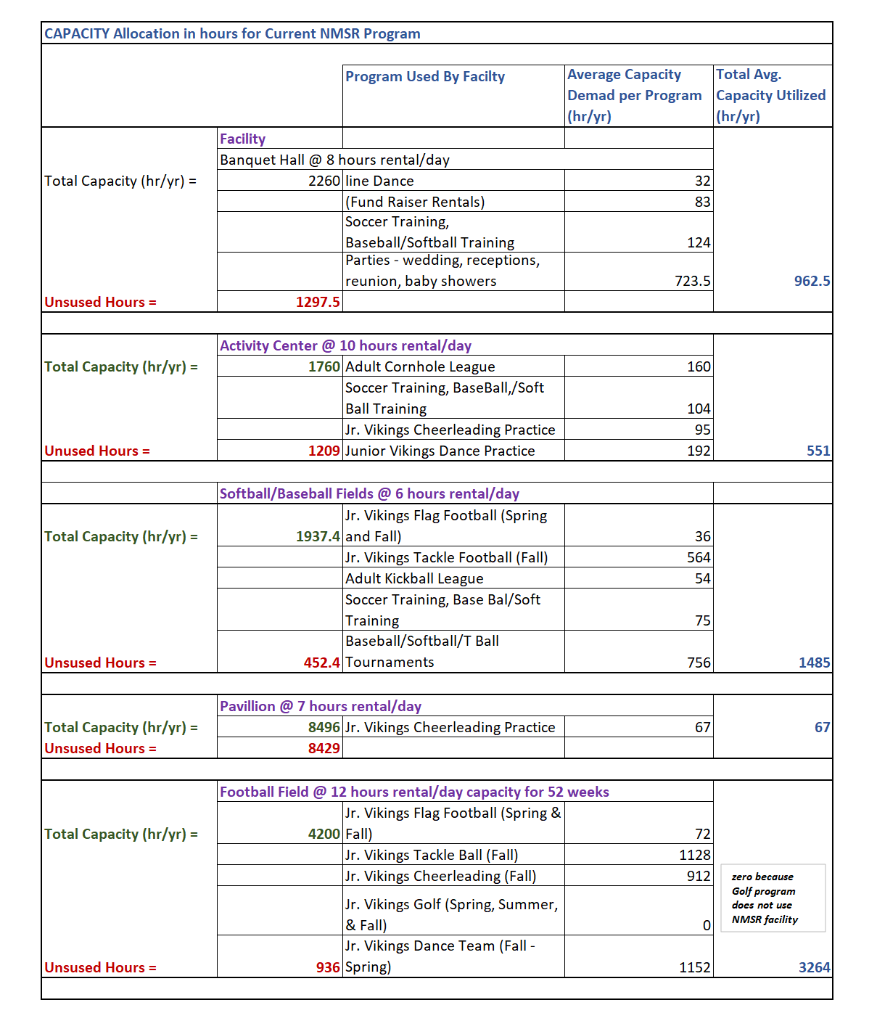

A comparison of Table 4.0 above and Table 1.0 shows that the Capacity Utilization of NSMR facility in both tables are approximately the same with the highest difference of just 6% for the activity center. Therefore, we are confident to use the same value and assumptions to plan for programs in the activity center.

***N/B- See Appendix 3 for explanations on the data Source and the estimation calculations of the average yearly demand and Capacity Allocation of current NMSR programs as shown in Table 4.0 above.***

4.2.2 Analyzing Capacity vs Demand of Current NMSR Products by using Pareto Chart

Fig. 1

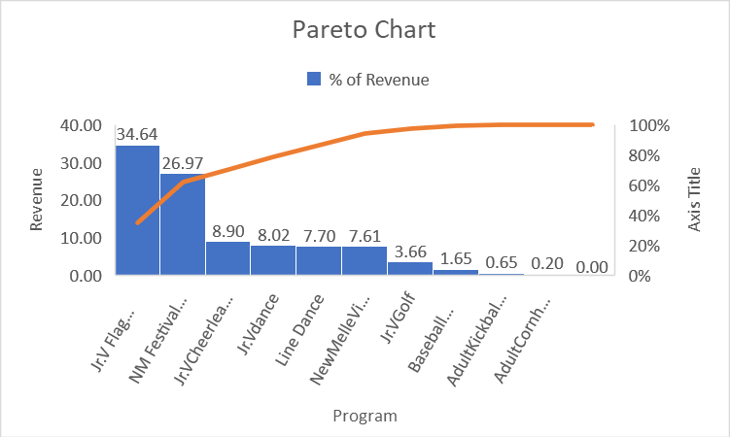

Based on the chart above, Viking Flag Football (Flag in Spring and Tackle in Fall) consists of 34.64 percent of the revenue, and New Melle's Festival and Halloween Event consists of 26.97 of the revenue. The two accounted for 61.6% of the revenue of NMSR. The Pareto chart shows that the top 2 products are mainly the revenue sources of NMSR.

The top five products are Jr. Viking Flag Football, New Melle's Festival and Halloween Event, Jr. Vikings Cheerleading (Fall), Jr. Vikings Dance and Line Dance, and they accounted for 86.26% of the total revenue. On the other hand, the remaining products have relatively low revenues, with the Adult Cornhole League being the lowest at 0.20% of total revenue.

Because line dance can bring higher income, we estimate that after launching more line dance programs, line dance income may eventually fall into the top 50% of the income sources of the Pareto chart.

Fig. 2

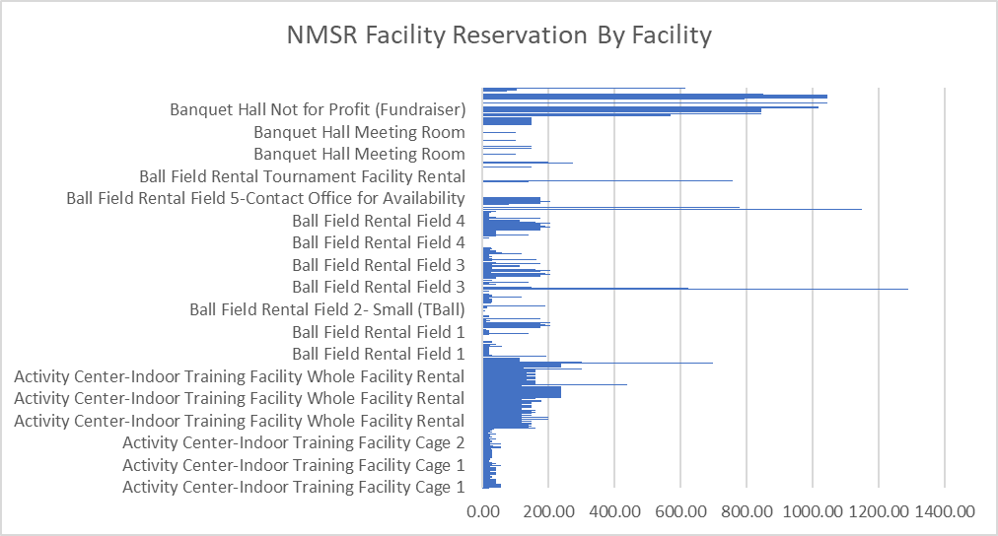

From figure 2 above, it can be seen that the facilities that are reserved the most host the programs that fell under the 80 percentiles of the pareto chart in figure 1, that is the Ball fields and the Banquet Hall. These are the Jr Vikings Flag Football, Jr Vikings cheerleaders, Jr Vikings Dance and line dancing.

NMSR may want to focus on expanding and enhancing its top revenue-generating products to maximize its revenue potential. To achieve this, they many want to focus on improving the capacity utilization of the Banquet Hall and Baseball fields that host these programs. These two facilities already have high-capacity utilization rates compared to the activity center and pavilions shown in Table 1.0. Although increasing their capacity utilization will undoubtedly generate more revenue, this research will concentrate on identifying ways to increase the capacity utilization of the Activity center from its current rate of 24.13% as shown in Table 1.0, to at least 50%."

4.3 Analyzing Demand for Activity Center

Table 5 - Activity Center/Batting Cages Programs and their Capacity Allocation (Current Utilization = 32%)

|  |  |
| --- | --- |
| **Program** | **Demand in hours**  **(Ref: Table 4.0** |
| Adult Cornhole League | 160 |
| Baseball/Softball/T Ball Training | 104 |
| Jr. Vikings Cheerleading Practice | 95 |
| Jr. Vikings Dance Team Practice | 192 |

***N/B- Activity center can be rented out as Batting Cages.***

Table 6 - Activity Center/Batting Cages Capacity Model/Calculating using 2022 Data

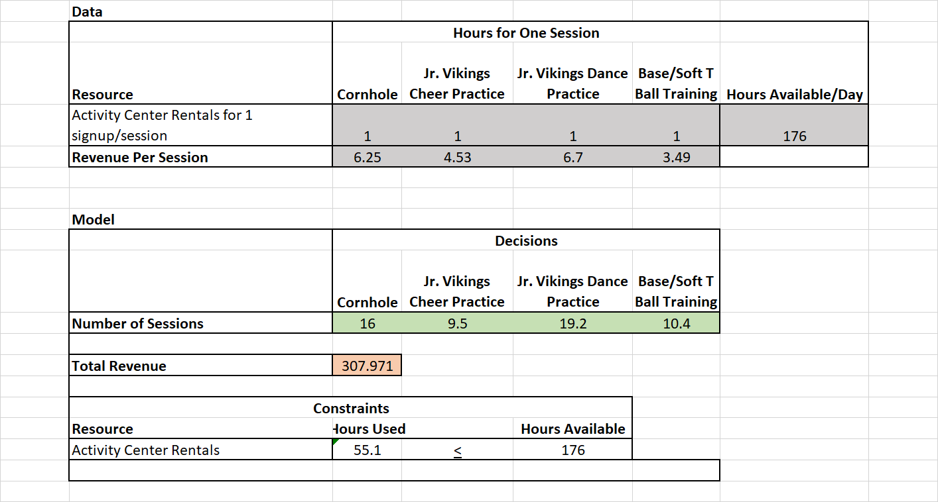

4.4 Recommendation on Increasing Capacity to at least 50%

To achieve this, we identified two programs that can be added to the activity center program from the list of new programs we proposed in section 3.1. Most of the proposed program can happen in the activity center but we chose the below new 2 programs because their investment costs are minimal.

* Mind and Body programs such as meditation, mindfulness, and stress reduction can attract individuals that are interested.
  + This can be done once bi-weekly. Totaling 25 days for 50 weeks in a Year. 2 weeks reserved for New Melle Halloween and Christmas event.

An Average of 8 hours/ day for several sessions (About three quarters of the estimated Capacity of the Activity center(10hrs/day)) = 25 x 8 = 200 hours/yr.

* + Average cost from Historic data in Saint Louis = $7/Hour (ThinkVidya Learning Pvt Ltd, n.d.).
* Senior Programs such as low-impact exercise classes, social events and educational seminars specifically for seniors.
  + Activities can include yoga, tai chi, or gentle stretching. These classes can help improve balance, flexibility, and strength, while reducing the risk of injury.
  + This can be done once bi-weekly. Totaling 25 hours for 50 weeks in a Year. 2 weeks reserved for New Melle Halloween and Christmas event.

An Average of 8 hours/ day for several sessions (About three quarters of the estimated Capacity of the Activity center(10hrs/day)) = 25 x 8 = 200 hours/yr.

* + Minimum cost of Yoga and tai chi classes in saint louis Missouri = $10 (Eckley, 2016).

Table 7 - Updated Activity Center/Batting Cages Programs and their Capacity Allocation (Forecasted Utilization = 54%)

|  |  |
| --- | --- |
| **Program** | **Demand in hours**  **(Ref: Table 4.0** |
| Adult Cornhole League | 160 |
| Baseball/Softball/T Ball Training | 104 |
| Jr. Vikings Cheerleading Practice | 95 |
| Jr. Vikings Dance Team Practice | 192 |
| Mind and Body Program | 200 |
| Yoga and tai chi Senior Programs | 200 |

Table 8 - Activity Center/Batting Cages Capacity Model – Updated with Proposed New Program

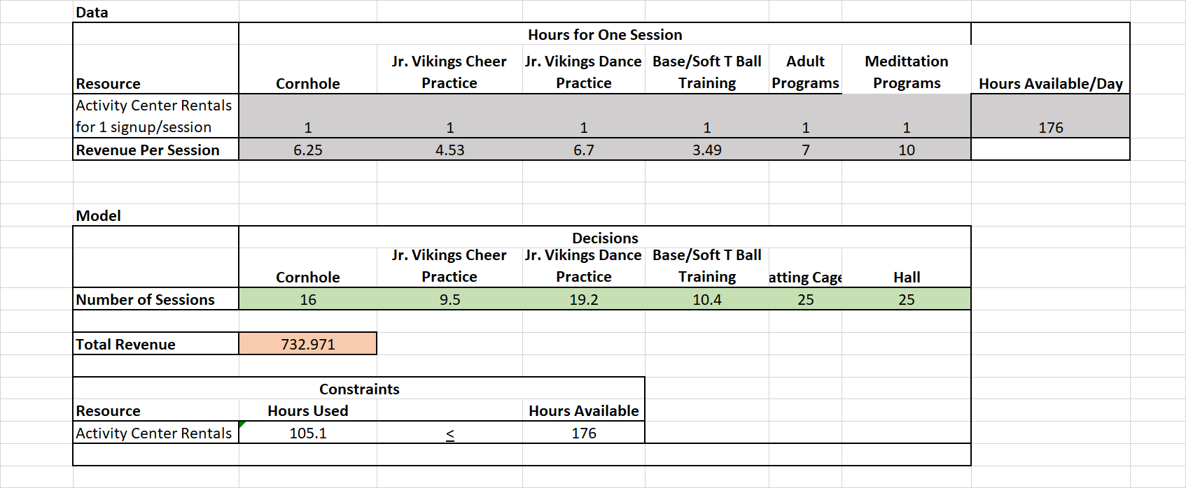

4.5 Activity Center Sales Forecast for 24 and 12 Months respectively

We used the daily demands in hours of the activity center from 2018 up to the 1st month in 2023 to forecast for 48 months and 24 months hourly demand of the activity center.

Fig. 3 – Activity Center Sales Forecast (24 Months)

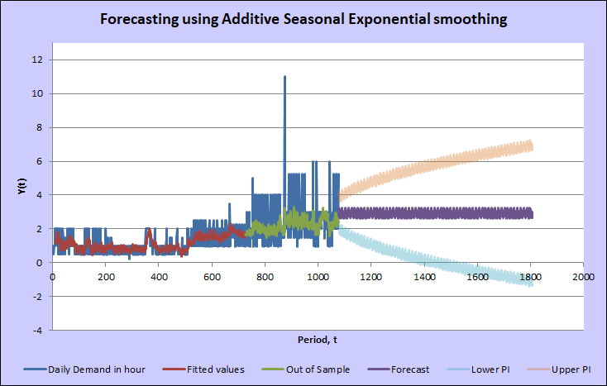

From Figure 3. above the Sales forecast did not perfectly fit the actual sales. And from Table 4 below the estimated MAPE is 0.3965 which is acceptable for the forecast to be used.

Table 9 – 24 Month's Forecast Metrics

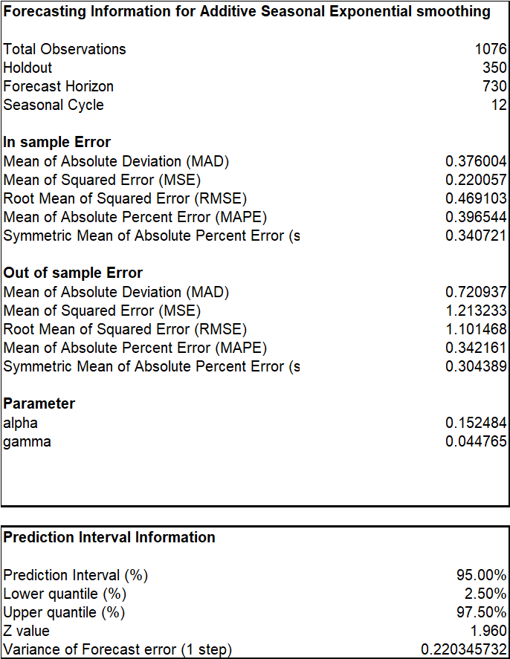

Fig. 4 – Activity Center Sales Forecast 12

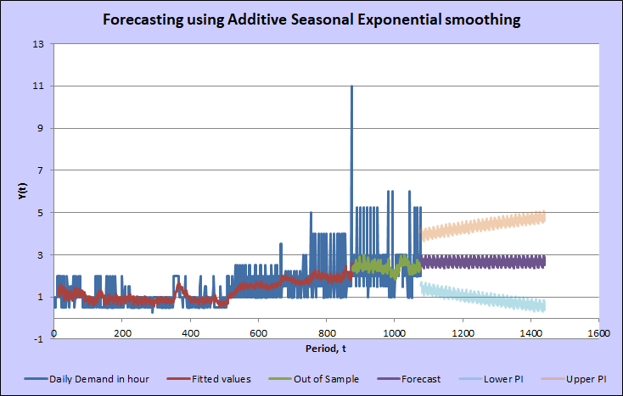

Table 10 – 12 Month's Forecast Metrics

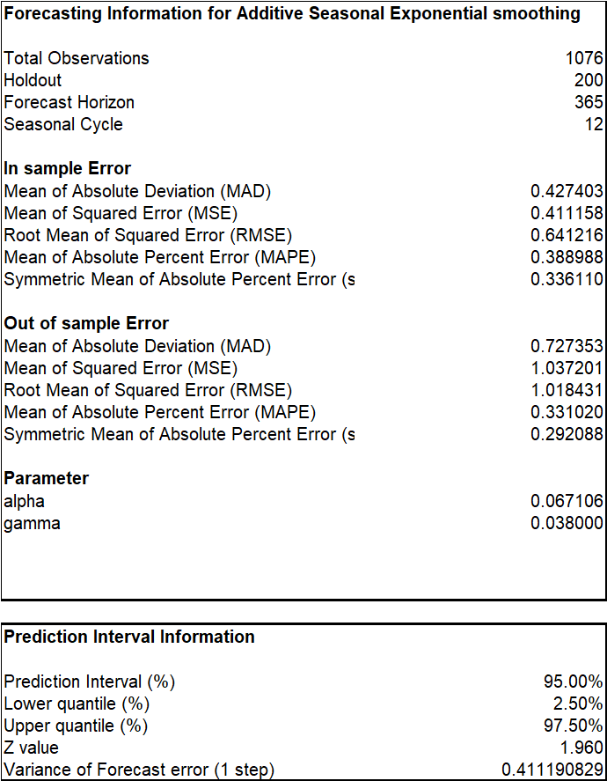

In the 12-month Forecast we held out lesser samples to see if we will get a better prediction. The MAPE value seems lower so we will be going with the prediction of the 14-month forecast.

The total number of demands in hours predicted for the next 12 months for the activity center is seen in Appendix 5.

This value totals about 133 Days.

The forecasted output data in an excel file shall be submitted to the faculty upon request. The data is over 2000 rows and cannot be appended in the appendix.

This value (133days) is still lower than the estimated capacity of the activity center (176 Days of 10 hours). Meaning that the activity center shall be able to meet up with all the forecasted demands.

1. ***- Process Improvement & Operations***

Process improvement refers to the systematic approach of analyzing and optimizing the existing business processes to improve efficiency, reduce waste, and increase productivity. The aim of process improvement is to identify areas where improvements can be made and implement changes that result in more efficient and effective processes (Izquierdo, 2022).

Operations, on the other hand, refer to the day-to-day activities that enable a business to function. Operations include activities such as manufacturing, sales, marketing, distribution, and customer service. Effective operations management involves ensuring that these activities are carried out efficiently and effectively, and that the resources of the organization are used in the most optimal way to achieve the desired outcomes.

Process improvement is an essential part of operations management, as it helps to identify inefficiencies and bottlenecks in processes that can negatively impact operations. By improving processes, operations can become more streamlined, productive, and efficient, resulting in better business outcomes. Effective operations management, in turn, requires a constant focus on process improvement to ensure that the organization is continually improving and adapting to changes in the business environment (Frevvoblog, 2022).

There are several areas and operations that need process improvement at New Melle Sports and recreation center, such as provision of various handicap access, provision of air-conditioning units for the batting cages, upgrading the scheduling software, Provision of lights for the football field and field 5, Improvement on the concession stand operation process and more.

The main aim of the project was to improve the lighting on fields not covered with lights and on the improvement on the concession stand operation’s process, so for the remainder of the project we focused only on the improvement of the lights in the football fields and (Fields 5 are rarely used for tournaments) and Improvement on the concession stand operation process.

From data provided by NMSR, Field 5 demand is about 12% of the Fields demand and about 5% of overall NMSR facility demand. Using the percentage to allocate revenue to only Field 5 results to a revenue estimate of $16,392 which is very low compared to the Football field revenue of $106,204.25 and Net Profit is 43,134.39. The return on investment on Field 5 will definitely not be comparable to the Football Field.

5.1 Five WHY’s and answers the Football Fields need the Lights.

1. New Melle Sports and Recreation currently has outdoor lights on only half of the park and the Football Field is not covered with the light.
2. The lack of outdoor light causes vision constraints and is needed to improve vision and overall safety. Installing proper lighting can help to improve visibility and reduce the likelihood of accidents.
3. The installation of the outdoor lights will increase playing hours and at the same time increase revenue. If the facility is not currently able to host evening games or events due to inadequate lighting, installing lights would allow for additional revenue-generating opportunities such as nighttime tournaments or events.
4. Installation of the outdoor lights will help in meeting demand. In situations where there is a high demand for football field usage but limited availability due to daylight hours, installing lights would help to meet this demand and potentially attract new customers.
5. Installation of outdoor lighting can enhance the overall game experience. High-quality lighting can help to create a more enjoyable and immersive experience for players and spectators alike, thereby enhancing the overall experience of using the facility (*YOUTH SPORTS | Newmellesports*, n.d.).

The above 5 WHY’s andswer’s has justified the need for New Melle Sports and recreation to invest on the installation of outdoor lightening on their Football field, but we looked further to see if the return on investment (ROI) justifies this investment.

5.2 Return on Investment (ROI) for the Installation of LED light fixtures and mounting brackets on the Football Fields

Return on Investment (ROI) is a financial metric used to evaluate the profitability of an investment or project. It measures the amount of return, or profit, generated from an investment relative to the amount of money invested.

ROI is calculated as follows: Return (Benefit)/Investment (Cost)

Return (Benefit) is the gain of the investment which can be the Net income and the investment is the total cost spent on the investment.

To calculate Return on Investment (ROI) for the installation of LED light fixture and mounting brackets on New Melle Recreation and Sports Football Fields we will use the 2022 income and expense data of the football field summarized below:

Football Field 2022 Income = $106,204.25

Baseball Field 2022 Expenses = $63,069.86

Football Field 2022 Net Income = $106,204.25 - $63,069.86 = $43,134.39

Proposed Investment = $117,562.00

(Quotation provided by American Electric & Data, Inc.

ROI = ($43,134.39/$117,562.00) x 100 = 36.69%

This means that the ROI for the proposed investment is approximately 36.69%. In other words, for every dollar invested, the project is expected to generate approximately 36.69 cents in net income.

5.3 Payback period on investment for LED light fixtures and mounting brackets installation on football fields

The payback period is a financial metric used to measure the length of time it takes for an investment to generate enough cash flow to recover its initial cost. In other words, it is the amount of time required for the investment to "pay back" its initial investment.

To calculate the number of years it will take to recover the investment for the Installation of LED light fixture and mounting brackets on the football field, we used the payback period method.

Payback period = Initial Investment / Annual Net Income

Plugging in the numbers from the quote, we get:

Payback period = $117,562.00 / $43,134.39

Payback period = 2.72 years (rounded to two decimal places)

Therefore, the payback period for this investment is approximately 2.72 years. This means that it will take approximately 2.72 years for the project to generate enough cash flow to recover its initial investment of $117,562.00.

5.4 Net Present Value (NPV) and Internal Rate of Return (IRR)

NPV is a measure of the net present value of future cash flows, discounted at the required rate of return. We assumed a required rate of return of 10%, and calculated the NPV as follows:

Year 1: $43,134.39 / (1 + 0.10) = $39,212.17

Year 2: $43,134.39 / (1 + 0.10)^2 = $33,197.16

Year 3: $43,134.39 / (1 + 0.10)^3 = $28,090.18

NPV = -$117,562.00 + $39,212.17 + $33,197.16 + $28,090.18

NPV = -$17,062.49 (rounded to two decimal places)

The negative NPV indicates that the project may not be profitable enough to justify the initial investment of $117,562.00.

IRR is the rate at which the NPV of the investment is zero.

Year 0: -$117,562.00 (Initial investment)

Year 1: $43,134.39 (Net cash inflow)

Year 2: $43,134.39 (Net cash inflow)

Year 3: $43,134.39 (Net cash inflow)

We calculated the IRR by using the trial-and-error method as the following steps:

First, we tried different discount rates until we found the one that makes the NPV equal to zero.

Second, we assumed a discount rate of 8% and calculated the present value of each cash flow using the discount rate. We Sumed up the present values of the cash flows to get the NPV. If the NPV is positive, the discount rate is too low. If the NPV is negative, the discount rate is too high. Third, we adjusted the discount rate and repeated the steps until we found the discount rate that makes the NPV equal to zero.

Ultimately, we found the IRR to be 8.5%.

5.5 Financial Metrics Summary for LED Light Fixtures and Mounting Brackets Installation on Football Fields

The payback period of 2.72 years suggests that the investment will take less than 3 years to pay back the initial investment. However, the negative NPV of -$17,062.49 indicates that the project may not be profitable enough to justify the initial investment. The IRR of approximately 8.5% suggests that the project may be profitable if the required rate of return is lower than 8.5%.

The Finacial Metrics calculated and summarized above to justify the proposed investment for the Installation of LED fixtures and mounting brackets on the football fields can be improved by the use of grants.

5.5 Proposal for a grant to cover the cost of installing LED light fixtures and mounting brackets for football fields

A grant is a form of financial assistance that is provided to individuals or organizations by a government agency, foundation, corporation, or other entity. Grants are typically provided for a specific purpose, such as supporting research, funding a project, or providing assistance to individuals or groups in need.

Grants are generally considered a form of non-repayable funding, and if granted can help improve the financial metrics for the proposed investment by providing additional funding that can reduce the upfront cost of the project. This, in turn, can lower the payback period and increase the return on investment. However, we are aware that grants may come with specific terms and conditions, such as restrictions on the use of the funds or reporting requirements, that must be adhered to. Therefore, we have carefully evaluated the terms and conditions of several grants New Mell Sports and Recreation can apply to and have recommended some that align with the current goal and objectives which is “The Installation of LED light and fixtures and Mounting brackets for the Football Fields”

5.5.1 Grants Researched

Below is a list of grants we researched that can benefit New Mell Sports and Recreation Projects.

1. **MLB-MLBPA Youth Development Foundation Grant**

Accepts application on a rolling basis.

1. **The National Recreation and Park Association (NRPA) Grant**

Deadline: March 31

1. **Snee-Reinhardt Charitable Foundation Grant**

Deadline: Second Tuesday in May

Second Tuesday in September

5.5.2 Proposed Grants and Its Requirements

**MLB-MLBPA Youth Development Foundation Grant**

The MLB-MLBPA Youth Development Foundation, a joint initiative between Major League Baseball and the Major League Baseball Players Association, was established to enhance youth baseball and softball participation and accessibility. The Foundation provides grants to organizations both domestically and abroad and accepts applications year-round. The Board of Directors reviews and decides on grant applications every quarter.

Application Link- <http://baseballydf.com/apply>

The areas of support include the following:

* Capital Projects: This covers the construction, renovation, and lighting of fields.
* Baseball and Softball Programs: Provide support for players, infrastructure, equipment, and other expenses such as coaches' training, background check fees, umpire fees, player registration fees, facility rental fees, and field maintenance.
* Education Initiatives: Fund programs, exhibits, and learning opportunities to promote interest and engagement in the game with baseball and softball as a primary focus
* Schools: Offer up to $5,000 for players and infrastructure equipment.

The areas of non-support include:

* Capital Projects with less than 50% of the project funding secured, including field and lighting projects
* Annual operating expenses, such as fundraising costs, salaries, fringe benefits, insurance costs, administrative expenses, membership dues, advertising and promotional expenses, bank charges, audit expenses, and other third-party overhead costs
* Travel teams with exception in programs supporting low-income youth players
* Construction of restrooms, concession stands, and classrooms
* Individual player scholarships or sponsorships
* Capital projects and uniforms for schools

**Submitting Letter of Inquiry (LOI)**

Email the below details to [**YDF@mlb.com**](mailto:YDF@mlb.com)

* Completed Information Form
* Introductory Letter
* Completed Budget Proposal

For more information: Email [YDF@mlb.com](mailto:YDF@mlb.com) or call (212) 931-7886

(*MLB-MLBPA Youth Development Foundation*, n.d.)

1. ***- Supply Chain/Operations Management***

Supply Chain Management (SCM) and Operations Management (OM) are two closely related fields that involve managing the flow of goods, services, and information from the point of origin to the point of consumption. Supply Chain Management (SCM) involves the coordination and management of all activities involved in the sourcing, procurement, production, and logistics of goods and services. While Operations Management (OM) is concerned with managing the transformation of inputs (e.g., raw materials, labor, capital) into outputs (e.g., products, services) that meet customer demand.

In the context of New Melle Sports and recreation activities, supply chain management involves managing the various suppliers, logistics, and distribution channels involved in delivering the necessary goods and services to support the programs and concession stand. New Melle Sports and recreation activities, supply chain management and operations management play crucial roles in ensuring the smooth functioning of the various programs and services offered by the organization. This includes managing the supply of equipment, food, and other resources required to support the programs and concession stand, as well as managing the operational processes involved in running the programs and concession stand efficiently and effectively. By optimizing these processes, New Melle Sports and recreation activities can ensure that it is able to provide high-quality programs and services to its customers while also managing costs and maintaining profitability.

6.1 Improvement on the concession stand operation process

New Melle Sports and Recreation can improve the operations process of their concession stand by optimizing their Inventory Management/Pricing.

Inventory management is a crucial aspect of concession stand operations, as it involves ensuring that the right products are available in the right quantities at the right time, while also minimizing waste and spoilage. By optimizing their inventory management processes, New Melle Sports and Recreation can ensure that they have the right amount of inventory on hand to meet demand, without tying up excessive amounts of capital in excess inventory.

In addition to inventory management, pricing is another important factor that can impact the operations of a concession stand. By setting prices that are competitive and attractive to customers, New Melle Sports and Recreation can increase demand for their products, leading to increased sales and revenue.

6.2 NMSR Menu, Cost and Price Analysis

Table 11 –NMSR Menu, Cost and Price

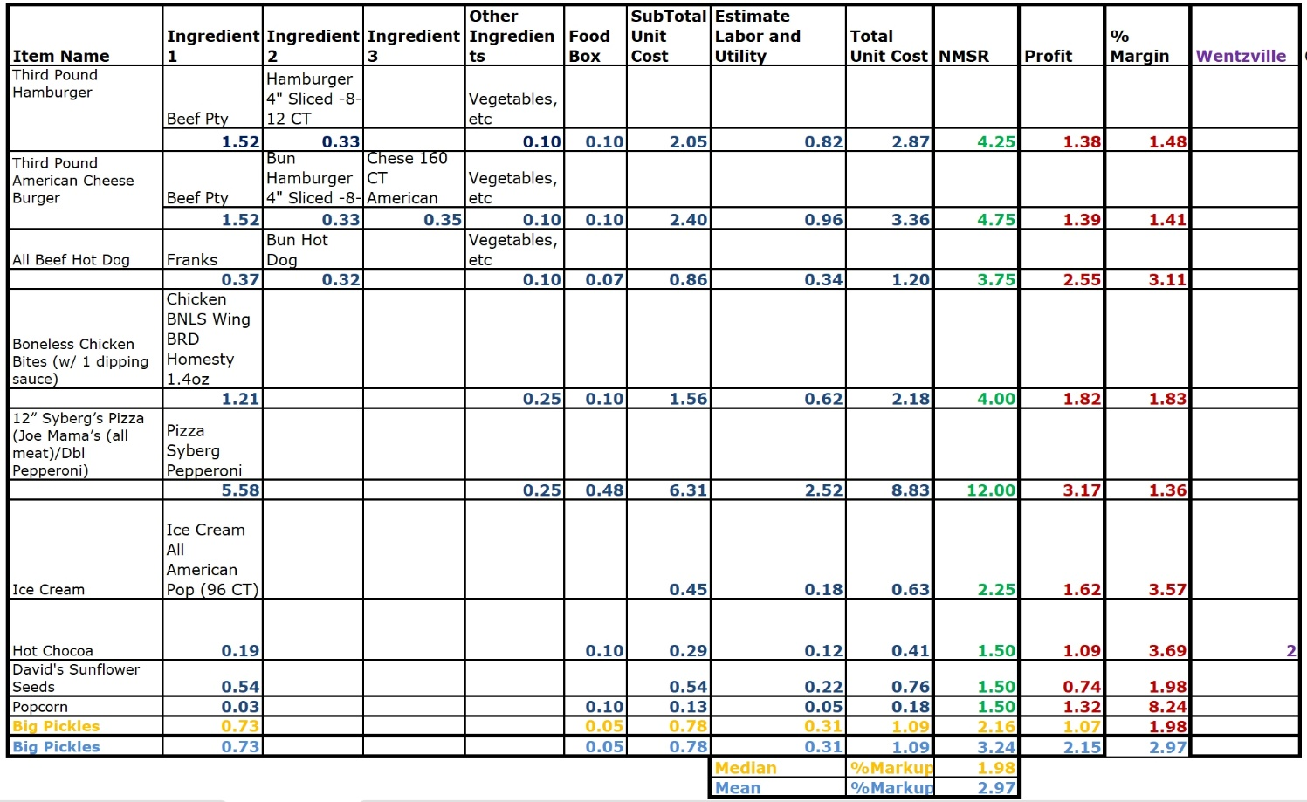

Table 1 above represents the most frequently sold items at New Melle Sports and Recreation Concession Stand.

The mean of the Profit margin for the 10 identified sample items is 2.97 and the median is 1.98.

The variation is 4.78 and the standard deviation is 2.19. And from the Line Graph below, it shows there is so much variation in the sample %margin data is not normally distributed.

Fig. 5 - Margin Line Graph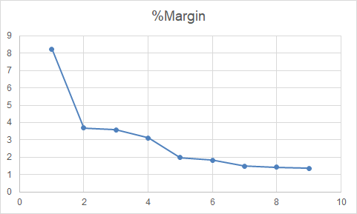

Changes that could help get a normal distribution of your data is by:

* To improve accuracy in calculating mean and median, we need more data samples as we were only able to gather cost and price information for 10 out of over 30 food items offered by New Melle Sports and Recreation. Proper documentation of cost and price is necessary, but it was difficult to obtain the total cost of a specific food item due to challenges in acquiring all the ingredients.
* To estimate labor and utility costs, we used a standard markup of 30% for labor and 10% for utilities, totaling 40% (Hilliard, 2022). However, a more detailed analysis is needed to assign the appropriate percentage for each item since labor and utility consumption may vary.

6.2.1 Labor Cost

We used the estimate production rate of a Hamburger to reconfirm our 30% Labour markup estimate in Table 11 above.

New Melle Can Produce 50 Burgers in an hour.

The Total unit cost of Hamburger = 2.87 x 50 = 143.5

Number of Labour for Hamburger = 1

Minimum Wage of Labour = $12/hour

30% x Unit cost (143.5) = Estimated Labour cost used in Table 11 = $43.05

We will retain the 30% labor estimate for the rest of our analysis since it yielded a higher labor wage for the hamburger, the excess will eventually be part of the profit.

**Additional Menu Analysis**

The pickles have been noted as highly sort after, the analysis we did on the cost and possible price is recommendable.

As shown in Table 8 above, we used both the mean and the median %margin value to mark up the cost to get the price. We shall be recommending using the median value at this point to mark up any new item since the sample data is not normally distributed. Our recommended Price for the Pickle is ($1.09 x 8 = $8.72) $8.72 for one serving of (2oz) 8 pickles. At this price, 12 Pickles will be approximately $13.08. This is lower than the one at $13.37 with 12 individually packaged pickles.

Overall, we’d recommend the bucket pickle because the average cost is lower. However, there are 3 advantages for individual packed pickle. 1.) The price difference is very small. 2.) It’s prepacked, so we won’t need to spend too much labor cost. 3.) It can be stored at room temperature, which is good for our limited refrigerator space.

6.3 Competitor Product Analysis and Sales Review

* ***Compare competitor’s concession stand – Wentzville Park&Rec***

1. Wentzville Park& Recreation charges hamburger/ cheeseburger for $5.00/$5.50. And for the same product, we only charge $4.25/$4.75. Although our prices are very competitive, we also suggest increasing them a bit, since most people who attend sports games come for their families in the sport programs and buy food from concession stands merely out of convenience. Thus, even if the price is raised, it shouldn't impact too much on sales.
2. Wentzville Park& Recreation sell big pickles for $2.00 each. It can be used as a reference for our future pricing pickle.
3. Also, they sell cotton candy for $5.00, which we don't have. This is one of the most profitable concessions stand foods. Therefore, we should consider selling this product (WebstaurantStore, 2023). Our recommendation pricing is $3.00 for each cotton candy cone (*Cotton Candy at Your Next Party or Event*, n.d.).

Pay Back Period for $157.7 for Commercial Cotton Candy Machine Electric Candy Floss Maker (*Toolots, Inc. - Reliable Equipment Fast.*, n.d.)

Table 12

|  |  |  |
| --- | --- | --- |
| **Selling Price** | **Profit** | **Pay Back** |
| $3 | $2.9 | 54.4 |

* Selling 55 cotton candies will pay off the machine cost.

Cost for Flossugar (*Gold Medal Flossugar Various (64 Oz., 6 Ct.) - Sam’s Club*, n.d.-b) and Cotton Candy Cones (*Gold Medal Cotton Candy Cones (1,000 Ct.) - Sam’s Club*, n.d.)

Table 13

|  |  |  |  |  |  |  |
| --- | --- | --- | --- | --- | --- | --- |
| **Product\Cost** | **Flossugar** | **Cones** | **Total cost** | **Selling Price** | **Profit** | **% Margin** |
| **Cotton Candy** | 0.07 | 0.027 | 0.01 | 3 | **2.99** | **300** |

* ***Compare competitor’s concession stand – Chesterfield***

Chesterfield Parks, Recreation & Arts Department usually have vendors apply to attend the events. The food price from vendors is normally much higher than ours, which is between $7 to $11 (*Log in or Sign up to View*, n.d.-d). Yet this price is from year 2018, which is outdated.

1. ***- Supplier Management***

Supplier management involves managing supplier relationships to ensure efficient and effective goods and services flow into an organization. It includes various activities like sourcing, selecting, negotiating, collaborating, and contract management to meet organizational objectives. Effective supplier management is crucial in improving supply chain, reducing costs, enhancing quality, and timely delivery. It involves aspects such as risk management, evaluating supplier performance, and contract management. A well-managed supplier network can give an organization a competitive edge in terms of cost, quality, and delivery, leading to overall success.

New Melle Sports and Recreation Center faces challenges and opportunities for improvement in supplier management. The report below discusses the issues related to supplier management identified in the context.

* Bullwhip Effect: Pepsi's online ordering option may lead to the bullwhip effect, causing inventory and supply chain issues.
* Inventory Issue with Cambell Soup: The center may face inventory issues due to Cambell's ordering approach.
* Ice Cream Cup Material Shortage: The center may need to explore alternative suppliers or consider making ice cream cups from scratch in case of a material shortage.
* Late Delivery: The center may have to purchase similar items from local stores or inform customers of out-of-stock items if there is a delay in delivery.
* Slush: A contingency plan is necessary to address stockouts of this irreplaceable item.
* Accuracy of Orders: The beer company requires a 100% accurate order, which calls for clear communication channels with suppliers and accurate information on order quantities and specifications.

**Options for New Melle Sports and Recreation to ensure Supply**

* Monitor supplier performance: context: Regularly monitoring suppliers is critical for identifying improvement areas and ensuring contract compliance, including delivery times, product quality, and other metrics. To ensure timely delivery, it is important to monitor lead times for different items, such as three days for food orders, one day for slush, and two weeks for Pepsi. Minimum order requirements must be met, or the center may need to wait or pick up the goods themselves. (Thomas, 2022).
* Establish clear expectations: New Melle Sports and Recreation Center should communicate their expectations to suppliers about product quality, delivery times, and other performance metrics. They need to manage orders and inventory correctly and consider lead times for each product when planning orders and inventory levels to avoid stockouts and delivery delays. This can enhance customer satisfaction and lower expenses related to stockouts and emergency orders. Effective lead time management can help guarantee enough inventory to fulfill client demand.
* Make Some Items from Scratch: To tackle the challenges related to inventory and supply chain, the center may consider producing some items from scratch. Although this approach could lead to cost savings, the center must carefully evaluate the time and resources required for the production process.
* Negotiate favorable terms: Negotiating favorable terms with suppliers, such as volume discounts or extended payment periods, can help reduce costs and improve cash flow.
* Foster collaboration: New Melle Sports and Recreation should foster collaboration with suppliers to build strong relationships and promote innovation. This can involve collaborating on product development, sharing information and resources, and exploring opportunities for mutual benefit.
* Diversify the supplier base: To reduce the risk of supply chain disruptions, New Melle Sports and Recreation should consider engaging multiple suppliers for each product category. This can help ensure that there are alternative sources of supply available in case one supplier is unable to deliver.
* Implement a just-in-time (JIT) inventory system: A JIT system can help minimize inventory holding costs and reduce the risk of spoilage or waste. Under this system, inventory levels are kept low, and products are only ordered from suppliers when needed, based on current demand.
* Utilize technology to streamline the procurement process: Technology such as procurement software can help streamline the procurement process, reducing administrative burden and improving accuracy. This can also provide real-time visibility into inventory levels and supplier performance.
* Consider implementing a vendor managed inventory (VMI) system: Under a VMI system, suppliers manage inventory levels at the concession stand, and products are automatically restocked when inventory levels fall below a certain threshold. This can help reduce the administrative burden and ensure timely delivery of products.

**Options New Melle Sports and Recreation should use in managing supply with companies that provide supply:**

* Set up recurring orders: Setting up recurring orders for regularly consumed products can help ensure a steady supply of products and reduce the risk of stockouts. This can benefit New Melle Sports and Recreation by providing a more reliable supply chain, reducing the risk of running out of products during peak demand periods, and freeing up time and resources that would otherwise be spent placing orders manually.
* Implement a vendor managed inventory (VMI) system: Implementing a VMI system can help reduce administrative burden and ensure timely delivery of products. This can benefit New Melle Sports and Recreation by reducing the need for manual inventory tracking, ensuring that products are available when needed, and improving overall supply chain efficiency.
* Implement a just-in-time (JIT) inventory system: Implementing a JIT system can help minimize inventory holding costs and reduce the risk of spoilage or waste. This can benefit New Melle Sports and Recreation by reducing inventory costs, minimizing waste and spoilage, and improving cash flow.
* Utilize electronic data interchange (EDI) systems: Utilizing EDI systems can help automate the procurement process and reduce errors and administrative burden. This can benefit New Melle Sports and Recreation by improving overall supply chain efficiency, reducing errors and delays in the procurement process, and freeing up time and resources that would otherwise be spent on manual tasks.
* Establish a safety stock level: Establishing a safety stock level can help ensure a buffer against unexpected demand or supply disruptions. This can benefit New Melle Sports and Recreation by reducing the risk of stockouts, improving overall supply chain reliability, and ensuring that products are available when needed.
* Conduct regular supplier performance reviews: Conducting regular performance reviews can help ensure that suppliers are meeting quality and delivery standards and can identify opportunities for improvement. This can benefit New Melle Sports and Recreation by ensuring that suppliers are meeting their contractual obligations, improving supplier relationships, and identifying opportunities for cost savings and process improvements.
* Foster collaboration with suppliers: Fostering collaboration with suppliers can help build strong relationships and promote innovation. This can benefit New Melle Sports and Recreation by improving supplier relationships, promoting new product development, and identifying opportunities for cost savings and process improvements.
* Use predictive analytics: Using predictive analytics can help forecast demand for products and improve inventory management. This can benefit New Melle Sports and Recreation by improving overall supply chain efficiency, reducing inventory costs, and ensuring that products are available when needed.
* Negotiate favorable payment terms: Negotiating favorable payment terms can help reduce the cost of goods and improve cash flow for New Melle Sports and Recreation. This can benefit the organization by improving overall financial performance and freeing up cash for other operational needs.
* Establish clear communication channels with suppliers: Establishing clear communication channels can help ensure that suppliers understand the needs of the concession stand and can provide timely and accurate information. This can benefit New Melle Sports and Recreation by improving supplier relationships, reducing errors and delays in the procurement process, and ensuring that products are available when needed.

7.1 Order Quantity and Safety Stock

Options Listed above to ensure supply of New Melle Sports and Recreation Food Supply at the right quantity and at the right time can be easily handled if the below three things are known:

* How much to order- Order Quantity
* How much safety stock is needed – Safety Stock
* When to Order – Re-Order Point

We shall summarize the analysis with made answering the above three questions in Table 14 below.

Table 14 – Order Quantity and Safety Stock for NMSR Frequently Sold Items

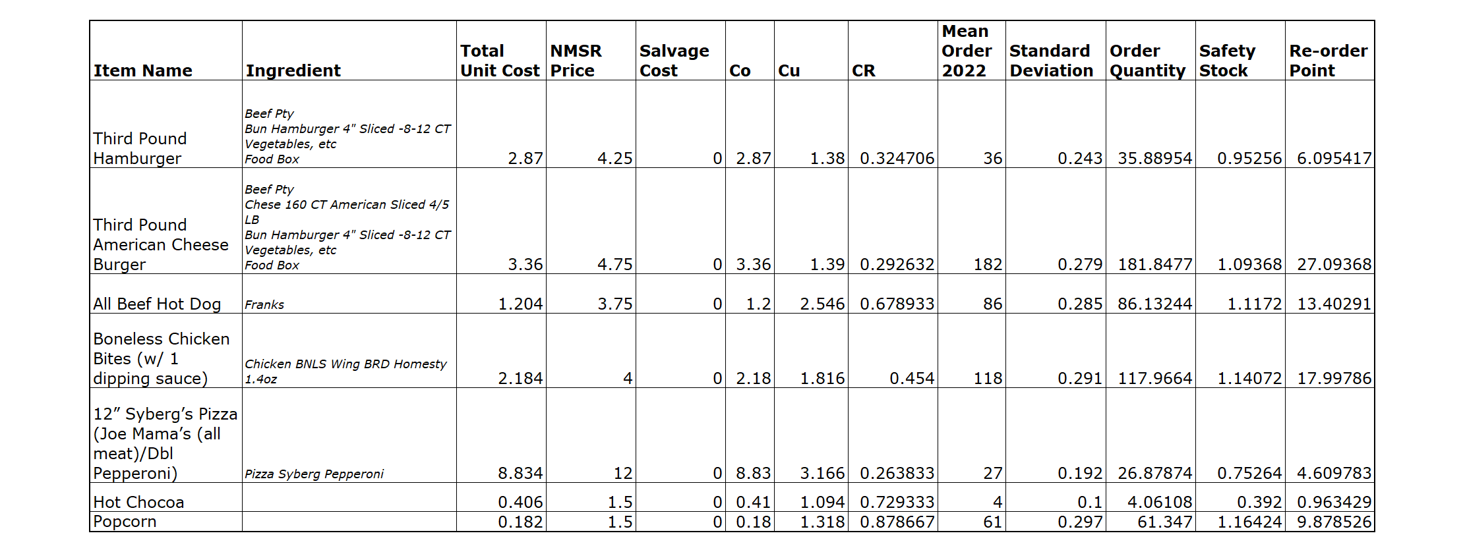

We used the concession sales data of January 2023 to find the mean and standard deviation we used to calculate the above data.

1. ***-Recommendations***

Establishment of low capital-intensive programs such as Mind and Body programs such as meditation, mindfulness, and stress reduction as well as Senior Programs such as low-impact exercise classes can increase the capacity utilization of the activity center.

Efficient Management of New Melle inventory and suppliers can be improved by NMSR:

* Knowing How much to order: - Order Quantity
* Knowing how much safety stock is needed: – Safety Stock
* Knowing when to Order: – Re-Order Point

Several new products can be introduced to New Melle concession stand to increase its profit generation. Cotton Candy with a profit margin of 300% is highly recommended.

New Melle proposedinvestment for LED light fixtures and mounting brackets installation on football fields has an ROIof36.69% and a payback period of 2.72 years. Also, the Net Present Value is Negative. It does not look feasible for a Non-Profit organization like NMSR, but a grant can help reduce the payback period.

**MLB-MLBPA Youth Development Foundation Grant** is highly recommended and application for this grant is on rolling basis.

1. ***- Conclusions***

Based on the above analysis, New Melle Sports and Recreation can become a world-class organization, competitive in cost, price, and quality, by focusing on quality improvement initiatives. The installation of outdoor lights on the football field can increase playing hours, revenue, and enhance the overall game experience. Additionally, optimizing the inventory management and pricing strategies for their concession stand can lead to increased sales and revenue. The center can also evaluate supplier management to ensure timely delivery and high-quality goods and services while reducing costs. By focusing on these quality improvement initiatives, New Melle Sports and Recreation can continue to improve its services and maintain profitability, leading to a successful future.

***10.0 - Personal Learnings on Consulting***

I had the privilege of working as a student consultant with the New Melle Sports & Recreation through Saint Louis University's supply chain consulting course. Our objective was to optimize their supply chain operations and identify any potential inefficiencies. We proposed innovative solutions, including the implementation of cutting-edge to enhance inventory tracking and streamlined order processing to reduce expenses and enhance customer satisfaction. This experience allowed me to apply theoretical knowledge to real-world scenarios, refine my problem-solving skills, and improve communication skills while making a positive impact on a local business. Overall, this collaboration exemplifies the importance of academic-enterprise partnerships in driving progress and fostering development.

- Gnan Srivarsh Bekkesula Narahari

My stint with the New Melle Sports & Recreation has been an immensely gratifying and enriching experience. I strongly believe that supply chain consulting serves as a pivotal instrument for businesses to sustain their competitive methods, and I am thankful for the opportunity to apply my expertise and acumen to drive positive change. This engagement has honed my skills and augmented my knowledge base, which will prove indispensable in my professional trajectory. I am confident that the New Melle Sports & Recreation will continue to reap the rewards of our recommendations and realize their goals.

- Hari Prasath Jothiswaran

It was an excellent class for learning supply chain-related consulting skills. The whole project was data driven to sort out the best recommendations for the organization’s improvement. We are taught to make our own insight after analyzing data resources, beyond what board members already know or can easily research online. If possible, I'd like to begin data analysis earlier to find out more approaches to deal with the issues we face, like incomplete information. Then we'd have more time to think deeper about the data analysis results.

- Yi-Hsuan Chan

This course has been an incredible opportunity to apply my theoretical knowledge in a practical setting and make a real impact on the organization. Through this course, I have been able to apply this knowledge in practice by working alongside my group members and NMSR board members. By participating in different activities, I have gained valuable skills in problem-solving, data analysis, and project management. I have gained a deeper understanding of the supply chain industry and how it impacts the local community. Moreover, the course helped me to learn the importance of strategic planning and effective communication in supply chain management.

- Renukalaxmi Dudhe

During my involvement in this course with New Melle Sports and Recreation, I gained valuable skills in operational and supply chain management, as well as soft skills such as teamwork, leadership, and communication. I also developed my data management skills and gained so many insights on how to apply both structured and unstructured data to valuable use. We conducted a thorough analysis of the organization's current model and identified gaps in their operations. We then developed potential solutions and optimized their supply chain through effective supplier management. This experience provided me with practical skills that can be applied in various industries and allowed me to work with business leaders in a real-world setting.

Jiderechukwu Becky Ogbodo

In this class, I have learnt many things working with my team, and it was a good experience that I gained supply chain skills because of the NMSR project that we hsave done the analysis on this and there are some of the presentations that can improve our communication skills we learned about SWOT analysis, capacity analysis every inch of the NMSR project. The main theme is by the collaboration with SLU (Saint Louis University), both the organizations will gain networking with each other. I have gained a good knowledge working with our team and have made us professionals in the supply chain.

- Yashwanth Majji

**References**

Competitive Capabilities International. (2022, March 31). *How to achieve operational excellence: 3 key components*. TRACC Solution. <https://traccsolution.com/blog/how-to-achieve-operational-excellence/>

Newmellesports. (n.d.). *About Us*. New Melle Sports and Recreation. <https://www.newmellesportsandrec.com/about-us>

Newmellesports. (n.d.). *About Us*. New Melle Sports and Recreation.<https://www.newmellesportsandrec.com/about-us>

*YOUTH SPORTS | Newmellesports*. (n.d.). Newmellesports. <https://www.newmellesportsandrec.com/youth-sports>

*Before you continue to Google Maps*. (n.d.). [https://www.google.com/maps/place/New+Melle+Sports+%26+Recreation/@38.7135876,-90.8777144,15z/data=!4m8!3m7!1s0x87deca37e8868e39:0x9913a351881c31a6!8m2!3d38.7135876!4d-90.8777144!9m1!1b1!16s%2Fg%2F1tcx_cpr](mailto:https://www.google.com/maps/place/New+Melle+Sports+%26+Recreation/@38.7135876,-90.8777144,15z/data=!4m8!3m7!1s0x87deca37e8868e39:0x9913a351881c31a6!8m2!3d38.7135876!4d-90.8777144!9m1!1b1!16s%2Fg%2F1tcx_cpr)

Kuligowski, K. (2023). Why You Need a SWOT Analysis for Your Business. *business.com*. <https://www.business.com/articles/swot-analysis-for-small-business-planning/>

Bennett, S. (2022). Corporate Social Responsibility (CSR) Statistics. *WebinarCare*. <https://webinarcare.com/best-corporate-social-responsibility-software/corporate-social-responsibility-statistics/>

*City of Chesterfield, Missouri | Pavilion Rental*. (n.d.). City of Chesterfield, Missouri 2023. <https://www.chesterfield.mo.us/pavilion-rental.html>

*Facebook*. (n.d.). <https://www.facebook.com/chesterfieldparks/>

PlanetTogether. (n.d.). *Capacity Analysis in Operations Management*. <https://www.planettogether.com/blog/capacity-analysis-in-operations-management>

ThinkVidya Learning Pvt Ltd. (n.d.). *Top 10 affordable meditation classes near St. Louis, MO*. UrbanPro.com. <https://www.urbanpro.com/usa/mo-st-louis/meditation-classes/32795041>

Eckley, E. (2016, February 18). *Where to find free and affordable yoga classes in St. Louis*. St. Louis Magazine. <https://www.stlmag.com/health/where-to-find-free-and-affordable-yoga-classes-in-st-louis/>

CCH, T. (2022, September 28). *Capacity Planning for service organizations: The value of scaling your business*. Back to top. Retrieved April 17, 2023, from <https://www.wolterskluwer.com/en/expert-insights/the-value-of-capacity-planning-process>

Waters, A. (2023, March 17). *The real-world benefits of volunteering for college students*. The Real-World Benefits of Volunteering for College Students. Retrieved April 17, 2023, from <https://www.galaxydigital.com/blog/benefits-volunteering-college>

Team, W. (2023, March 16). *Demand planning*. WallStreetMojo. Retrieved April 17, 2023, from <https://www.wallstreetmojo.com/demand-planning/>

Zycus. (2018, December 13). *Supplier management- benefits, process, & best practices*. zycus. Retrieved April 17, 2023, from <https://www.zycus.com/blog/supplier-management/understanding-supplier-management-its-benefits-process-and-best-practices>

*MLB-MLBPA Youth Development Foundation*. (n.d.). baseballydf.com. <https://www.baseballydf.com/apply>

Thomas. (2022, November 1). *Reorder point formula and safety stock: A complete guide*. inFlow Inventory. Retrieved April 17, 2023, from <https://www.inflowinventory.com/blog/reorder-point-formula-safety-stock/>

Izquierdo, R. (2022, August 5). *How to implement process improvement: 6-Step Approach*. The Motley Fool. Retrieved April 17, 2023, from <https://www.fool.com/the-ascent/small-business/project-management/articles/process-improvement/>

Frevvoblog. (2022, February 16). *Continuous process improvement: Benefits and strategies*. frevvo Blog. Retrieved April 17, 2023, from <https://www.frevvo.com/blog/continuous-process-improvement/>

WebstaurantStore. (2023). Concession Stand Food Ideas: Popular & Profitable Ideas. *WebstaurantStore*. <https://www.webstaurantstore.com/article/76/concession-stand-food-ideas.html>

*Log in or sign up to view*. (n.d.-d). <https://www.facebook.com/CityOfChesterfield/photos/a.164580533591757/1566620970054366/>

*Toolots, Inc. - Reliable Equipment Fast.* (n.d.). <https://www.toolots.com/ng-frontend/productDetail?id=59148&title=Commercial%20Cotton%20Candy%20Machine%20Electric%20Candy%20Floss%20Maker&gclid=CjwKCAjw__ihBhADEiwAXEazJn901EgVvSgv-xLPJQug0i35gzn-NLS9DmRdmzO4YDM2HazDQEGlpBoCpVYQAvD_BwE>

*Cotton Candy At Your Next Party or Event*. (n.d.). STLSnowCone. <http://stlsnowcone.com/catering-fun-foods-pricing/cotton-candy/>

*Gold Medal Flossugar Various (64 oz., 6 ct.) - Sam’s Club*. (n.d.). Sam’s Club. <https://www.samsclub.com/p/gold-medal-flossugar-various-flavors/143036>

*Gold Medal Cotton Candy Cones (1,000 ct.) - Sam’s Club*. (n.d.). Sam’s Club. <https://www.samsclub.com/p/floss-cotton-candy-cones-1-000/143041?xid=plp_product_8>

` Hilliard, B. (2022, October 14). *Labor cost percentage by industry - are you spending too much*. Adia. <https://adia.works/blog/labor-cost-percentage-by-industry/>

***Appendix 1 – Calculations for Actual Capacity (In hrs./yr.)***

1. ***Banquet Hall***
   1. ***Non-Availability is shown below:***

New Melle Festival = 1 week

Passion Play = 1 week

New Melle Halloween Event = 1 weekend = 3 days

New Melle Christmas Event = 1 weekend = 3 days

***Total = 2 weeks 6 days = 20days***

* 1. ***Availability for booking:***

= Total of 52 weeks (1yr) – 2 weeks, 6 days (Unavailability) = 49.14 Weeks/yr.

Available for reservation- Monday, Wednesday, Friday, Saturday, and Sunday = 5 Days in a week.

Average Estimated number of hours can be reserved in the afore mentioned days = 8

Sub Total in a week = 8 x 5 = 40

Tumbling Classes are reserved Tuesdays and Thursdays (5-8pm) = 3 x 2 = 6hr/week

Total Hours of Banquet Hall in a week = 40 + 6 = 46

Total Hours of Banquet Hall in a Year = 46 x 49.14 week = 2,260.44 hours

≈ **2,260 Hours/yr**

1. ***Activity Center (Turf Field and Batting Cages)***
   1. ***Non-Availability is shown below:***

New Melle Festival = 1 week

New Melle Halloween Event = 1 weekend = 3 Days

Turkey Toss Cornhole Tournament = 1 Weekend = 3 Days

New year day = 1 Day

Cornhole League = 6 weeks

***Total = 8 weeks***

* 1. ***Availability for booking:***

= Total of 52 weeks (1 yr.) – 8 weeks = 44 Weeks /yr

Estimated Number of hours it can be reserved Sunday to Saturday between 6am- 11pm = 10 hours *(N/B - Estimated 2 hours to be used as set up and tear down time)*

Total number of hours in a year = 10 hours x 44 weeks = 440

For 4 Cages = 440 x 4 = 1760

***(N/B The Cages and the Turf Field cannot be rented out at the same time. So, we multiplied with 4, 4 represents either 4 cages or Turf fields.***

1. ***Softball/Baseball Fields (Fields 1, 2, 3, 4, & 5)***
   1. ***Non-Availability is shown below:***

December – February = 3 Months = 12 Weeks

Tuesdays and Wednesdays April to July = 2 days in a week x 4 Months (16 weeks) = 32 Days = 4 weeks 4 days

New Melle Festival = 1 week

New Melle Halloween Event = 1 weekend = 3 Days

Turkey Toss Cornhole Tournament = 1 Weekend = 3 Days

Kickin’ It for Cancer Kickball Tournament = 1 Weekend = 3 Days

Kickball Tournament = 1 day x 6 weeks = 6 days

***Total = 19 weeks 5 days***

* 1. ***Availability for booking:***

Total weeks available in a year:

= Total of 52 weeks in a year – 19 weeks 5 days non-Availability = 32.29 Weeks

Estimated reservation hours Monday – Friday, 4pm – 11pm = 7 hours

Estimated reservation hours Saturday – Sunday, 6am – 11pm = 5 hours

Total hours available in a week = 12 hours

Total number of hours in a year = 12 hours x 32.29 weeks = 387.48 Hours

**= 387.48**

For the 5 Fields = 5 x 387.48 = 1937.4 **hours**

1. ***Football/Soccer Practice Field***

Does not get rented out – only used by Jr. Vikings Football/Cheer

Assumed to be rented out 50 weeks (52 weeks - 2 weeks) in a year for 12 hours per day.

The 2 weeks will account for the New Melle’s Festival and Halloween Event.

Assumed Capacity in hours = 50 weeks x 7days x 12 hours = 4200 hours

1. ***Pavillions (2).***
   1. ***Non-Availability is shown below:***

New Melle Festival = 1 week

New Melle Halloween Event = 1 weekend = 3 days

***Total = 1 week 3 days = 9 days***

* 1. ***Availability for booking:***

= Total of 52 weeks in a year – 1 week, 3 days non-Availability = 50.57 Weeks

Estimated hours it can be reserved in a day (6am-11pm) = 12 hours (*(N/B -*  *Estimated 5 hours to be used as set up and tear down time)*

Estimated hours it can be reserved in a week (7 days) = 12 x 7 = 84 hours a week

Total Hours of Pavillion rental in a Year = 84 x 50.57 week = 4,247.88 hours

≈ **4248 Hours**

**For 2 Pavilions = 2 x 4248 = 8496**

1. ***Playground/Basketball Court.***

Public Use at any time – no charge

***Appendix 2 – Calculations for Average yearly Demand (Output Capacity) in hrs - (2018-2023) and Utilization***

1. ***Banquet Hall***

(Rentals from November 13, 2018, to Jan 2, 2023, (4.08 yrs.)

* 1. *Banquet Hall Meeting Room = 1669.73*
  2. *Banquet Hall Not for Profit (Fund Raiser) = 908.6*
  3. *Banquet Hall Receptions/Reunions/Parties = 1348.7*

*Total Rental for Banquet Hall for 4.08 yrs = 3,927.03*

***Average rental demand per year*** *= 3,927.03/4.08 = 962.5 hrs./year*

***Utilization of the Banquet Hall*** *= Demand/Capacity x 100 = 962.5/2260 x100 = 42.59%*

1. ***Activity Center - (Turd Field and Batting Cages***

(Rentals from November 5th, 2018, to Feb 2, 2023, (4.17 yrs.)

* 1. *Training Facility Cage 1 = 335.75*
  2. *Training Facility Cage 2 = 84.50*
  3. *Training Facility Cage 3 = 37.50*
  4. *Training Facility Cage 4 = 30.50*
  5. *Whole Facility Rental = 1282.75*

*Total Rental for Banquet Hall for 4.17 yrs = 1,771*

***Average rental demand per year*** *= 1786.5/4.17 = 424.70 hours/year*

***Utilization of the Banquet Hall*** *= Demand/Capacity x 100 = 424.70/1760 x100 = 24.13%*

1. ***Softball/Baseball Fields***

(Rentals from November 5th, 2018, to Feb 2, 2023, (4.75 yrs.)

* 1. *Ball Field Rental Field 1 = 955.25*
  2. *Ball Field Rental 2 – Small (TBall) - 238.5*
  3. *Ball Field Rental Field 3 = 1088.75*
  4. *Ball Field Rental Field 4 = 1137*
  5. *Ball Field Rental Field 5 = 631.25*
  6. *Ball Field Rental Games = 541.27*
  7. *Ball Field Rental Tournament - = 2512.25*

*Total Rental for Banquet Hall for 4.75 yrs = 7104.27*

***(N/B 2512.25 represents capacity for the 5 fields and football fields (6 Fields), the games and rental tournament are***  ***part of the field rentals)***

***Average rental demand per year*** *= 7104.27/4.75 = 1495.64 hours/year*

***Utilization of 5 Filed + Football Field =*** *Demand/Capacity x 100 = 1495.64/1937 x100 =*  *77.21%*

1. ***FootBall/Soccer Field***

*(Rented out for* Jr. Vikings Football/Cheer)

*Jr. Vikings Football/Cheer Rental*

* 1. *Jr. Vikings Flag Football (Spring & Fall) = 72*
  2. *Jr. Vikings Tackle Football (Fall) = 1128*
  3. *Jr. Vikings Cheerleading (Fall) = 912*
  4. *Jr. Vikings Golf (Spring, Summer, & Fall) = 0 (Does not use NMSR Facility)*
  5. *Jr. Vikings Dance Team (Fall-Spring) = 1152*

*Total of Jr. Vikings Football/Cheer Rental = 326.4*

*Assumed Utilization = 3492/4200 = 77.71*

1. ***Pavillion (2)***

(Rentals from November 5th, 2018, to Feb 2, 2023, (4.25 yrs.)

* 1. *Pavillion 1 (Beside Basketball Field) = 85.98*
  2. *Pavillion 2 (Adjacent to Concession) = 143.92*

*Total Rental for Banquet Hall for 4.25 yrs = 229.9*

*(****Average rental demand per year*** *= 229.9/4.25 = 54.1 hours/year*

***Utilization of 2 Pavilion's =*** *Demand/Capacity x 100 = 54.1/8494 x100 =*  *0.64%*

1. ***Playground/Basketball Court.***

Public Use at any time – not paid for – Demand not recorded

***Appendix 3 - Estimation of average yearly demand and Capacity Allocation of current NMSR current program***

The calculation of facility capacity allocation for each program is based on the average total number of days and hours that each program occurs in a year. This information was obtained from "NMSR's Spread Sheet: Reservations by program 2018 - current". The total number of hours each program occurs in a year was determined by multiplying the total number of days by the number of hours the facility can operate in a day. Appendix 3 provides details on how the estimated number of hours each facility can host a program in a day was determined.

**I. Banquet Hall**

Programs that held in the Banquet Hall are listed below:

*1. Line Dance*

This is planned to be held 4 times a year.

At 8 hours per day rental of the banquet hall, the estimated total number of hours the Banquet Hall will be rented out for the line dance in a year will be:

= 4 x 8 = 32 hours/year

*2. Fund Raiser Rentals*

Fund Raiser Rentals are held on an average of 18 days in a year.

For an 8 hour /day rental of the banquet hall, the average number of hours the Banquet Hall will be rented out for (Fund Raiser Rentals) is:

= 18 x 8 = 144 hours

*3. Soccer Training, Base Ball/Soft Ball Training*

Soccer Training, Base Ball/Soft Ball Training held on an average of 31 days in a year.

Soccer Training, Base Ball/Soft Ball Training can take place in the Banquet Hall, Activity Center, and Softball/Baseball Field.

We assumed Soccer Training, Base Ball/Soft Ball Training held on equal days at these three facilities, so for Banquet Hall the total number of days it hosted the Soccer Training, Base Ball/Soft Ball Training will be:

=31/3 = 10.33 days.

For an 8 hour /day rental of the banquet hall, the average number of hours the Banquet Hall will be rented out for (Soccer Training, Base Ball/Soft Ball Training) is:

= 10.33 x 8 = 83 days Approximately

*4. Parties Weddings, Reunions, Baby Showers*

The number of Days the Banquet Hall was rented out for Parties, Weddings, Reunions, Baby Showers was not recorded in the spreadsheet.

From Table 1.0, Banquet Hall Average Demand in a year = 962.5hr

Total of Line Dance, Fund Raiser Rentals, and Soccer Training, Base Ball/Soft Ball Training average capacity demand calculated above is:

32 + 144 + 83 = 259

We assume the remaining capacity demand should account for rentals for Parties Weddings, Reunions, Baby Showers. Then, the estimated total number of hours the Banquet Hall will be rented out for Parties Weddings, Reunions, Baby Showers will be:

962.5 - 259 = 703.5

For Weddings, Reunions, Baby Showers and Parties in the Banquet Hall, divide 703.5 by 8 = 88 days approximately

**II. Activity Center**

Programs that held in the Activity Center are listed below:

*1. Adult Cornhole League*

Adult Cornhole League held on to an average of 16 days in a year.

For a 10 hour /day rental of the Activity Center, the average number of hours the Activity Center will be rented out for (Adult Cornhole League) is:

= 16 x 10 = 160 hours

*2. Soccer Training, Base Ball/Soft Ball Training*

Soccer Training, Base Ball/Soft Ball Training held on an average of 31 days in a year.

Soccer Training, Base Ball/Soft Ball Training can take place in the Banquet Hall, Activity Center, and Softball/Baseball Field.

We assumed Soccer Training, Base Ball/Soft Ball Training happened on equal days at these three facilities, so for Activity Center the total number of days it hosted the Soccer Training, Base Ball/Soft Ball Training will be:

=31/3 = 10.33 days.

For a 10 hour/day rental of the banquet hall, the average number of hours the Activity Center will be rented out for (Soccer Training, Base Ball/Soft Ball Training) is:

= 10.33 x 10 = 104 Approximately

*3. Jr. Vikings Cheerleading Practice*

Jr. Vikings Cheerleading happened on an average of 95 days in a year.

Using Pareto principal, we assume that 20% of this is for Practice, Jr. Vikings Cheerleading Practice also happens in the Pavillion. The days are assumed to be shared equally. Therefore, the activity center will be equal to (20%)/2 of 95:

= 10% x 95 = 9.5

For a 10 hour /day rental of the Activity Center, the average number of hours the Activity Center will be rented out for (Jr. Vikings Cheerleading Practice) is:

= 9.5 x 10 = 95 hours Approximately

*4. Jr. Vikings Dance Practice*

Jr. Vikings Dance held on an average of 96 days in a year.

Using Pareto principal, we assume that 20% of this is for Practice. This will be equal to 20% of 96:

= 20% x 96 = 19.2

For a 10 hour /day rental of the Activity Center, the average number of hours the Activity Center will be rented out for (Jr. Vikings Dance Practice) is:

= 19.2 x 10 = 192 hours (about 1 week 1 day)

**III. Softball/Baseball Fields**

Programs that happen in the Softball/Baseball Fields are listed below:

*1. Jr. Vikings Flag Football (Spring & Fall)*

Jr. Vikings Flag Football (Spring & Fall) happened on an average of 12 days in a year.

Jr. Vikings Flag Football (Spring & Fall) also happened in the Football Field.

We assumed Jr. Vikings Flag Football (Spring & Fall) happened on equal days at these two facilities, so for Softball/Baseball Fields the total number of days it hosted the Jr. Vikings Flag Football (Spring & Fall) will be:

=12/2 = 6 days.

For a 6 hour /day rental of the Softball/Baseball Fields, the average number of hours the Softball/Baseball Fields will be rented out for (Jr. Vikings Flag Football (Spring & Fall) is:

= 6 x 6 = 36

*2. Jr. Vikings Tackle Football (Fall)*

Jr. Vikings Tackle Football (Fall) happened on an average of 188 days in a year.

Jr. Vikings Tackle Football (Fall) also happened in the Football Field. We assumed Jr. Vikings Tackle Football (Fall) happened on equal days at these two facilities, so for Softball/Baseball Fields the total number of days it hosted the Jr. Vikings Tackle Football (Fall) will be:

=188/2 = 94 days.

For a 6 hour /day rental of the Softball/Baseball Fields, the average number of hours the Softball/Baseball Fields will be rented out for (Jr. Vikings Tackle Football (Fall) is:

= 94 x 6 = 564

*3. Adult Kickball*

Adult Kickball happened on an average of 9 days in a year.

For a 6 hour /day rental of the Softball/Baseball fields, the average number of hours the Softball/Baseball fields will be rented out for (Adult Kickball) is:

= 9 x 6 = 54hours

*4. Soccer Training, Base Ball/Soft Ball Training*

Soccer Training, Base Ball/Soft Ball Training happened on an average of 31 days in a year.

Soccer Training, Base Ball/Soft Ball Training can take place in the Banquet Hall, Activity Center, and Softball/Baseball Field.

We assumed Soccer Training, Base Ball/Soft Ball Training happened on equal days at these three facilities, so for the Softball/Baseball fields the total number of days it hosted the Soccer Training, Base Ball/Soft Ball Training will be:

=31/3 = 10.33 days.

For a 6 hour /day rental of the Softball/Baseball Field, the average number of hours the Softball/Baseball Field will be rented out for (Soccer Training, Base Ball/Soft Ball Training) is:

= 10.33 x 6 = 62 Approximately

*4. Baseball/Softball/T Ball Tournaments*

Baseball/Softball/T Ball Tournaments happened on an average of 286 days in a year.

For a 6 hour /day rental of the Softball/Baseball fields, the average number of hours the Softball/Baseball fields will be rented out for (Baseball/Softball/T Ball Tournaments) is:

= 126 x 6 = 756 hours

**IV. Pavillion**

Programs that happen in the Pavillion are listed below:

*1. Jr. Vikings Cheerleading Practice*

Jr. Vikings Cheerleading happened on an average of 95 days in a year.

Using Pareto principal, we assume that 20% of this is for Practice. Jr. Vikings Cheerleading Practice also happens in the Activity Center. We assume the days are shared equally. So, for the activity center This will be equal to (20%)/2 of 95:

= 10% of 95 = 9.5

For a 12 hour /day rental of the Pavillion, assuming 5 hours is used for setting up and tear down, the average number of hours the Activity Center will be rented out for (Jr. Vikings Cheerleading Practice) is:

= 9.5 x 7 = 67 hours Approximately

**V. Football Fileds**

Programs that happen in the Football Fields are listed below:

*1. Jr. Vikings Flag Football (Spring & Fall)*

Jr. Vikings Flag Football (Spring & Fall) happened on an average of 12 days in a year.

Jr. Vikings Flag Football (Spring & Fall) also happened in the Softball/Baseball fields.

We assumed Jr. Vikings Flag Football (Spring & Fall) happened on equal days at these two facilities, so for Softball/Baseball Fields the total number of days it hosted the Jr. Vikings Flag Football (Spring & Fall) will be:

=12/2 = 6 days.

For a 12 hour /day rental of the Football Field, the average number of hours the Softball/Baseball Fields will be rented out for (Jr. Vikings Flag Football (Spring & Fall) is:

= 6 x 12 = 72 hours

*2. Jr. Vikings Tackle Football (Fall)*

Jr. Vikings Tackle Football (Fall) happened on an average of 188 days in a year.

Jr. Vikings Tackle Football (Fall) also happened in the Football Field. We assumed Jr. Vikings Tackle Football (Fall) happened on equal days at these two facilities, so for Softball/Baseball Fields the total number of days it hosted the Jr. Vikings Tackle Football (Fall) will be:

=188/2 = 94 days.

For a 12 hour /day rental of the Football Field, the average number of hours the Softball/Baseball Fields will be rented out for (Jr. Vikings Tackle Football (Fall) is:

= 94 x 12 = 564

*3. Jr. Vikings Cheerleading (Fall)*

Jr. Vikings Cheerleading (Fall) happened on an average of 95 days in a year.

20% is already allocated for the Jr. Vikings Cheerleading Practice. Total hours remaining for Jr. Vikings Cheerleading (Fall) is:

= 80% x 95 = 76

For a 12 hour /day rental of the Football fields, the average number of hours the football fields will be rented out for (Jr. Vikings Cheerleading (Fall) is:

= 76 x 12 = 912 hours

*4. Jr. Vikings Dance Team (Fall - Spring)*

Jr. Vikings Dance Team (Fall - Spring) happened on an average of 96 days in a year.

20% is already allocated for the Jr. Vikings Dance Practice. Total hours remaining for Jr. Vikings Dance (Fall - Spring) is:

= 80% x 96 = 76.8

For a 12 hour /day rental of the Football fields, the average number of hours the football fields will be rented out for (Jr. Vikings Cheerleading (Fall) is:

= 76.8 x 12 = 922 hours Approximately.

*5. Jr. Vikings Golf (Spring, Summer, & Fall)*

Jr. Vikings Golf (Spring, Summer, & Fall) happened on an average of 93 days in a year

Does Not use NMSR facilities. (Off-site on golf course)

***Appendix 4 - Estimation Activity Center Program Capacity and Revenue (Capacity Model)***

N/B Activity Center can also be used as Batting Cages

Total Capacity in hours per year = 1760 (Ref: Table 1)

Estimated Hours Available per day = 10 Days (Ref: Appendices 1)

Total Days per year = 1760/10 = 176 Days

**Current Programs in the Activity Center**

Adult Corn Hole

Number of Session

Total Demand in hours per year = 160

Divide by 10 (Available hours/day of activity center) = Approximately 16 Days Demand per year.

Revenue Per Session

2022 Registration Fee = $100 /day

Estimating equivalent for 1 day = 100/16 = Approximately $6.25/day

Baseball/Softball/T Ball Training

Number of Practice Session

Total Demand in hours per year = 104

Divide by 10 (Available hours/day of activity center) = Approximately 10.4 Days Demand in a year

Revenue Per Session

Monthly Registration Fee = Average of Spring and Winter Sessions for age groups.

Ages 7U and up =$49

Ages 3-5 coed =$127

Ages 5-7 = $137

7/8U Softball= = $195

7/8U Baseball = $195

9-12U Softball = $205

9-12U Baseball = $205

13/14U = $339

Total = 1452

Average = $181.5

This implies that daily fee will be = $185.11/10.4= $17.45 per day

From Appendix 4 it was assumed that 20% of Baseball/Sfftball/TBall demand is for training.

Here we will also assume that 20% of the of Baseball/Sfftball/TBall revenue is from training.

Therefore Baseball/Sfftball/TBall per revenue per day can be equalled to: (20%) x $17.45b = Approximately $3.49

Jr. Vikingss Cheerleading Practice

Number of Practice Session

Total Demand in hours per year = 95

Divide by 10 (Available hours/day of activity center) = Approximately 9.5 Days Demand in a year

Revenue Per Session

2022 Registration Fee = $215 per 9.5 days in a year

Estimating equivalent for 1 day = 215/9.5 = Approximately $22.63/day

From Appendix 4 it was assumed that 20% of Jr. Vikings Cheerleading (Fall) demand is for the Practice.

Here we will also assume that 20% of the Jr. Vikings Registration is for Practice.

Therefore Jr. Vikings Cheerleading practice registration per day can be equaled to: (20%) x $22.63 = Approximately $4.53

Jr. Vikingss Dance Team Practice

Number of Practice Session

Total Demand in hours per year = 192

Divide by 10 (Available hours/day of activity center) = Approximately 19.2 Days Demand in a year

Revenue Per Session

Monthly Registration Fee = $185.11

This implies that daily fee will be = $185.11/30 = $6.17 per day

For 19.2 days = $6.17 x 19.2 =$118.46

Estimating equivalent for 1 day = 215/9.5 = Approximately $22.63/day

From Appendix 4 it was assumed that 20% of Jr. Vikingss Cheerleading (Fall) demand is for the Practice.

Here we will also assume that 20% of the Jr. Vikings Registration is for Practice.

Therefore Jr. Vikings Cheerleading practice registration per day can be equaled to: (20%) x $22.63 = Approximately $4.53